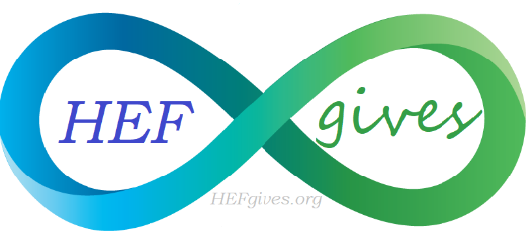
Holistic Education Foundation
PO Box 255, Palm City, Florida 34990
(772) 208-7688
www.HEFgives.org

Leap Year Yoga Challenge
Volunteer Application
February 29th 2020 Riverbend Park, Jupiter Florida

Name & Business (if applicable):____________________________________________________________________

Address: _________________________________________________________________________________________

Phone & E-mail:___________________________________________________________________________________

Website:__________________________________________________________________________________________

T-Shirt style (circle one):
V-Neck T-shirt Tank Top

Size: (circle one):
X-small Small Medium Large X-Large

AFFILIATION (circle one):
Holistic Education Foundation Stuart Holistic Chamber of Commerce Holistic Health Connections

APPLICATION FOR ENTRY CONSTITUTES AN AGREEMENT WITH THE HOLISTIC EDUCATION FOUNDATION LLC (HEF) THE VOLUNTEER WILL NOT TAKE ANY LEGAL ACTION AGAINST HEF OR ITS AGENTS FOR LOSS, DAMAGE, PERSONAL INJURYS ARRISING IN ANY MANNER AT THE LEAP YEAR YOGA CHALLENGE.
____________________________________________________________ _____________________________
Signature Date
PLEASE INITIAL AFTER EACH:
- Application must be completed & received by October 20, 2020
- Applicant must be available for November photo shoot, January meeting, and attend 3 meetings in February.
- Applicant agrees to promote education in holistic health and the Leap Year Yoga Challenge.
- Applicant agrees not to sell or solicit any product or service for their own benefit unless express permission is granted in writing to the person or company that will profit.
- If applicable, you are required to submitted your insurance which includes coverage for the Leap Year Yoga Challenge.
- Contact Catherine O’Connor with questions (772) 208-7688 HEFgives@gmail.com

