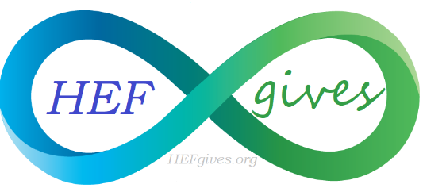
Holistic Education Foundation
PO Box 255
Palm City, Florida 34990
(772) 208-7688
info@HEFgives.org
www.HEFgives.org

Leap Year Yoga Challenge
VENDOR APPLICATION

Saturday February 29, 2020
8:00am-1:00pm
Riverbend Park, Jupiter Florida

BUSINESS NAME & AGENT____________________________________________________________________

PRODUCT/SERVICE: __________________________________________________________________________

ADDRESS: ____________________________________________________________________________________

PHONE/EMAIL:_______________________________________________________________________________

WEBSITE: _____________________________________________________________________________________

AFFILIATION (circle one):

Holistic Education Foundation Stuart Holistic Chamber of Commerce Holistic Health Connections

APPLICATION FOR ENTRY CONSTITUTES AN AGREEMENT WITH THE HOLISTIC EDUCATION FOUNDATION LLC. (HEF) THE EXHIBITOR/VENDOR WILL NOT TAKE ANY LEGAL ACTION AGAINST HEF OR ITS AGENTS FOR LOSS, DAMAGE, PERSONAL INJURYS ARRISING IN ANY MANNER AT THE LEAP YEAR YOGA CHALLENGE.

____________________________________________________________ _____________________________
Signature Date
PLEASE INITIAL AFTER EACH:
- Application and payment due by January 9th 2020
- Company logo must be submitted by January 9th 2020
- Set up at 7:00am, break down not before 1:00pm, mandatory vacate premises 3:00pm
- Each vendor is asked to donate 1 item for a raffle.
- Bring your own table ~Limited tables/chairs available for additional $25
- Contact Catherine O’Connor with questions (772) 208-7688 HEFgives@gmail.com

