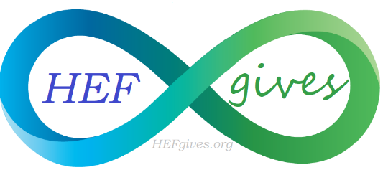
Holistic Education Foundation
PO Box 255, Palm City, Florida 34990
(772) 208-7688
www.HEFgives.org

Leap Year Yoga Challenge
Yoga Studio Participation Application
February 29th 2020 Riverbend Park, Jupiter Florida

Business name & contact person:____________________________________________________________________

Address: _________________________________________________________________________________________

Phone & E-mail:___________________________________________________________________________________

Website:__________________________________________________________________________________________

T-Shirt style (circle one):
V-Neck T-shirt Tank Top

Size: (circle one):
X-small Small Medium Large X-Large

AFFILIATION (circle one):
Holistic Education Foundation Stuart Holistic Chamber of Commerce Holistic Health Connections

APPLICATION FOR ENTRY CONSTITUTES AN AGREEMENT WITH THE HOLISTIC EDUCATION FOUNDATION LLC (HEF) THE STUDIO AND/OR ITS REPRESENTATIVE WILL NOT TAKE ANY LEGAL ACTION AGAINST HEF OR ITS AGENTS FOR LOSS, DAMAGE, PERSONAL INJURYS ARRISING IN ANY MANNER AT THE LEAP YEAR YOGA CHALLENGE.

____________________________________________________________ _____________________________
Signature Date
PLEASE INITIAL AFTER EACH:
- Application must be completed & received by October 20, 2020
- Company logo must be submitted via email to HEFgives@gmail.com by October 20, 2020
- Representative must be available for November photo shoot, January meeting, and send a representative to the Leap Year event that can call 10 sun salutations.
- Agree to register a minimum of 10 yogis who will raise $108 each & participate in the challenge.
- You are required to submit your insurance which includes coverage for the Leap Year Yoga Challenge.
- Contact Catherine O’Connor with questions (772) 208-7688 HEFgives@gmail.com

