*Join Holistic Education Foundation*

*108 Sun Salutations*

***Holistic Education Foundation\* PO Box 255 \* Palm City\* Florida \* 34990 \* (772) 208-7688 \* www.HEFgives.org***

*Benefits*

*Requests*

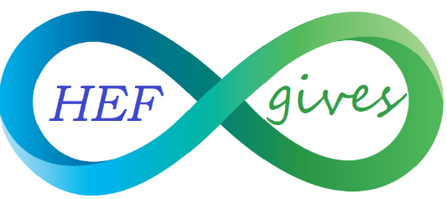*Support Education in Holistic Health*

* There is no financial cost to your studio.
* *Your studio name will be featured on* 
  + *HEF’s website & social media accounts.*
  + *the event flyers,*
  + *any and all print advertising that promotes 108 Sun Salutations for Holistic Education.*
* *Complimentary lunch at the event,*
* *Complimentary T-shirt,*
* *Complimentary goodie bag.*
* *We will refer clients live near your studio when HEF is contacted about this event.*
* *Your yoga students will be able to participate in a fun & fulfilling event.*
* *You will make the world a better place.*

* *Have a minimum of 10 Yogis raise $108 per person. They can ask family & friends to support them with a donation. (Checks made to Holistic Education Foundation are tax-deductible.)*
* *Your studio can register & collect the donation, or have your Yogis register on HEF’s website.*
* *Have a representative from your studio attend a Photo shoot for press release in November, and attend the meeting on February 8th 3pm at Piper’s Landing. (Light refreshments will be served.)*
* *At the event the Studio owner (or a teacher of your choosing) will lead 10 sun salutations.*